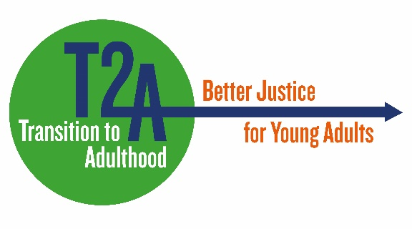
T2A communications consultancy
£250 per day inc VAT
Background
Transition to Adulthood (T2A) is a project and campaign of Barrow Cadbury Trust’s (BCT) criminal justice programme, promoting a distinct approach to policy and practice relating to young adults.
To help us achieve our goals we work with an alliance of organisations that operate at the intersection between young adults and the criminal justice system. We use Trust grants to fund research, demonstration projects and practical tools for criminal justice practitioners, develop policy proposals and make the case for a better response by the criminal justice system to this group. Details of our work can be found at www.t2a.org.uk.
In the last 10 years T2A has seen increasing traction with the Ministry of Justice, the National Probation Service, and Police and Crime Commissioners on the principle that young adults should be considered as a group with a unique set of needs by the criminal justice system. The concept is widely embedded within policy and guidance, however, widespread implementation of policies into practice is still some way off.
We recognise that to achieve our aims one area we need to focus on is communicating T2A’s messages and promoting its extensive back catalogue of reports, guides, and briefings, as well as finding new and better ways to disseminate upcoming work and build on our existing profile – particularly on digital platforms. Our main target audiences are criminal justice practitioners and policy makers.
Currently the majority of T2A’s communications work is carried out by Barrow Cadbury Trust’s Communications Manager and the Criminal Justice Programme Manager, with public affairs support from a freelance consultant. We are looking for someone to join up these different elements. This role would have oversight of our social media, T2A website (a new website is being developed and will be launched in 2022) and e-news/alerts, as well as identifying other appropriate social media platforms such as LinkedIn, that will help us connect with our target audiences. The post-holder will also be involved in seeking additional opportunities to share T2A’s research such as identifying speaking engagements at criminal justice conferences for the Chair of the T2A Alliance and sourcing opportunities for T2A to report its work in the specialist sector press.
A recent digital review has made a number of recommendations for T2A which we are keen to implement as soon as possible. T2A is already regarded by many as the ‘go to’ place for information and evidence on young adults in the CJS and we want to widen its reach and impact.
Tasks to be undertaken
This consultancy role will report to Barrow Cadbury’s Communication Manager. To ensure that the communication messages are aligned to the aims of the T2A campaign the post holder will meet regularly with the Trust’s Criminal Justice Programme Manager.
The following list of tasks is indicative and is expected to take up to eight days per month but include frequent monitoring of our social media feeds:
Social media:
- Source and draft daily/weekly content for Twitter, including simple infographics and images where appropriate
- Liaise with grant holders and stakeholders to support and disseminate their work
- Develop and build Twitter conversations on relevant topics
- Develop new Twitter contacts and relationships
- Monitor Twitter analytics and present monthly reports
- Create a new T2A LinkedIn page and source and draft content, create and engage in discussions where appropriate
- Draft and source content for e-news and e-alerts
Website:
- Keep website up to date and regularly review content
- Create new content and update existing content
- Source visuals for website
- Monitor website analytics and present monthly reports
Other communications activities:
- Drafting publicity content such as press releases, newsletters, website copy etc.
- Where useful to the communications role, attending T2A launches and events.
- Recording media coverage and measuring impact of publicity campaigns on audience engagement
- Developing and disseminating information materials that increase visibility among stakeholders
- Supporting the BCT Communications Manager undertake market research and audience analysis.
Skills and experience
- Two or more years of communications experience
- A particular interest and experience in social media and digital comms, including drafting and developing website content
- Broad criminal justice experience and interest in the T2A concept
- Experience of delivering communications support as an independent consultant
Terms
This is a consultancy so it will be up to the consultant to arrange their own working hours. However, they will be expected to regularly spend time in the Trust offices, including attending monthly campaign management group meetings, to ensure good communications across the team. We anticipate this being a medium to long term relationship for the right partner.
How to apply
If you would like to be considered for this role please send your CV and an email or 2 sides of A4 outlining the reasons for your interest in the role to Diana Ruthven, d.ruthven@barrowcadbury.org.uk.

